February 2021
Pacific Northwest Shrine Clown Association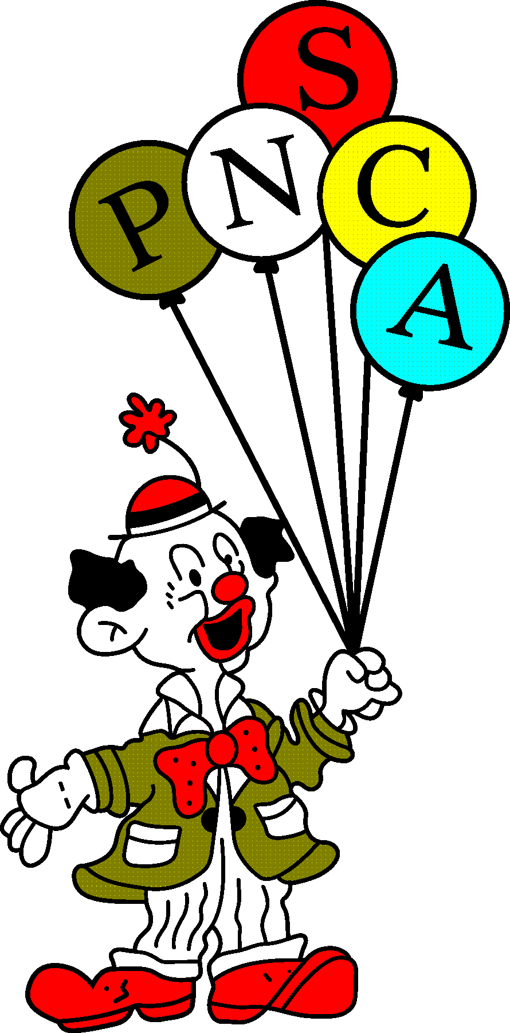

From the President: Rick Shumilak
P.N.S.C.A. report
Greetings fellow PNSCA Joeys

First, I want to wish everyone, all the best in the coming year, and do as Imperial Sir Jim Smith

As we put an almost non-existent year of Clowning and meeting for PNSA/ PNSCA and Imperial session behind us, we need to look ahead, on what we need to do to communicate this year. The prospect of having competitions or a PNSCA Annual General Meeting in person, doesn’t look promising. Living in Canada, I can not see myself being able to attend the sessions in Seattle. I feel that having a ZOOM meeting would be the way to go, to update our fellow joeys in the Pacific Northwest and even having a virtual Annual General Meeting. I will be contacting the PNSA Temple Recorders to get the Clown Presidents emails to invite their unit members to this ZOOM meeting. This may be the way of the future.

Our Clown unit didn’t participate in any parades this year, but were still able to do a walk-by of a few hospitals and senior centers and had a chance to display our calliope at a drive by parade. Just goes to show, we can still show off as clowns and have some fun!

In closing, Stay Healthy, Stay Safe and always remember the words in our Creed that unite us through our purpose around the world.
"Shriners believe in God and that He created man to serve His purpose, among which is service to others in His name"

Rick Shumilak
PNSCA President

From the 1st Vice President: Dan Sterkel
Joeys,
Just a quick note, COVID-19 has raised Havoc with all of our Shrine and Clown events. I am looking forward to getting out there and doing what we do best, having some fun, putting smiles on peoples faces, and getting back to some normal events.
As of present, PNSA summer session is scheduled to take place July 28th to 31st in Seattle, Washington. Mark your calendars!!
I am looking forward to having some fun and interacting with all of you--it has been too long. Get your people fired up and get your skits and balloons ready to go. Let's have a great turn out. Remind your ladies that they also can participate and are encouraged to join us. They have greatly added to the festivities, and make the whole event so much more exciting.
We are planning to have our annual meeting via zoom on February 16th. Information will be forthcoming. Let's make the best of a challenging time. We encourage everyone to participate. It will be an easy way for everyone to get involved.
It has been extremely difficult in these times, and I am ready to move on. Mark your calendar and get ready to have some fun. We all
deserve and need it. July 28-30th.

I look forward to seeing all of you

Yours in the faith,
Dan Sterkel

From The 2nd Vice President: Gary Semaniuk
His report is unavailable at this time.

From the Secretary/Treasurer: Chris Ellard
Hi Joeys
I am hoping that you and your loved ones have made it through the challenging times of 2020 Safely. We are also praying that the year ahead is one of healing, rejoining with our loved ones and understanding what the challenges are ahead. As you can see from the letters of our President and Vice President, that our exact future has yet to be determined and we will need to plan to manage whatever cards we are dealt. No matter what cards we end up with, we must ensure that the safety and both physical and mental well being of our immediate and Shriner families is our first priority.
As stated above the 2021 PNSA is slated for late July in Seattle, Washington and may or may not actually occur. If it does not occur, we will make a virtual meeting occur so we can touch base with the issues that need to be dealt with and just to say “Hi”. If the physical PNSA does occur we will do our best to ensure a Clown PNSCA competition takes place. However, it is unlikely that those of us from Canada will be in attendance due to border restrictions and/or quarantine expectations.
Dan has mentioned we are planning to hold a Zoom virtual meeting on February 16, 2021. This meeting will replace the 2020 AGM that did not occur and there needs to be some Notice of Motions brought forward so we can vote on them at the 2021 AGM in whatever format it ends up. Please see the Discussion item below.
From Last years Newsletter: The structure of our PNSCA’s have changed dramatically in the last few years as we try to make best use of our present participation #’s. Last year our female clowns were permitted to participate and compete in the contests beyond the Powderpuff costume and makeup competitions. They participated in all aspects of our competitions and points were awarded to the Temple they are affiliated with. Having our female clowns participating almost doubled our competitor numbers and enabled us to enjoy more paradeabilitiy and skits. We will be discussing this structure and the future of our PNSCA once again at the AGM.
Note: I am looking at stepping down as Secretary Treasurer of the PNSCA after this year so please ask your fellow Joeys if one of them would be willing to step up and take on this role.
As you have already been made aware, our web page is the go-to place for our members to get the PNSCA info they need. Please use the attached link to access this website and review all the updated PNSA and PNSCA information.
https://shrinerspnsa.wildapricot.org
Wear a mask – Spread the word, not the virus
Fraternally
Chris Ellard (Kwivers)
1-780-542-7291
lleeyard@gmail.com

